1. What are the features of React?

### JSX:  JSX stands for Javascript XML and it is a very useful tool for React developers. JSX is an extension of the JavaScript language which provides a way to structure component rendering using syntax similar to HTML.

### Components: Components are the building blocks of any React application, and a single app usually consists of multiple components. It splits the user interface into independent, reusable parts that can be processed separately.

### Virtual DOM: React keeps a lightweight representation of the real DOM in the memory, and that is known as the virtual DOM. When the state of an object changes, virtual DOM changes only that object in the real DOM, rather than updating all the objects.

### One-way data-binding: React’s one-way [data binding](https://www.simplilearn.com/tutorials/angular-tutorial/angular-data-binding) keeps everything modular and fast. A unidirectional data flow means that when designing a React app, you often nest child components within parent components.

### High performance: React updates only those components that have changed, rather than updating all the components at once. This results in much faster web applications.

### 2. What is JSX?

### JSX stands for Javascript XML and it is a very useful tool for React developers. JSX is an extension of the JavaScript language which provides a way to structure component rendering using syntax similar to HTML. JSX gives us the ability to write HTML elements in Javascript and place them in the DOM by converting the HTML tags into React elements without the need for other methods like createElement() or appendChild(). This combination of Javascript and HTML leads to having more powerful applications with boosted performance.

### **3. Can web browsers read JSX directly?**

* Web browsers cannot read JSX directly. This is because they are built to only read regular JS objects and JSX is not a regular JavaScript object
* For a web browser to read a JSX file, the file needs to be transformed into a regular JavaScript object. For this, we use Babel

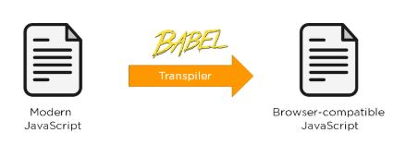

### **4. What is the virtual DOM?**

DOM stands for Document Object Model. The DOM represents an HTML document with a logical tree structure. Each branch of the tree ends in a node, and each node contains objects.

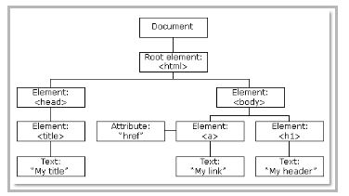

React keeps a lightweight representation of the real DOM in the memory, and that is known as the virtual DOM. When the state of an object changes, the virtual DOM changes only that object in the real DOM, rather than updating all the objects.

### **5. Why use React instead of other frameworks, like Angular?**

### Easy creation of dynamic applications: React makes it easier to create dynamic web applications because it provides less coding and provides more functionality, whereas, with JavaScript applications, code tends to get complex very quickly.

### Improved performance: React uses virtual DOM, which makes web applications perform faster. Virtual DOM compares its previous state and updates only those components in the real DOM, whose states have changed, rather than updating all the components — like conventional web applications.

### Reusable components: Components are the building blocks of any React application, and a single app usually consists of multiple components. These components have their own logic and controls, and they can be reused through the application, which, in turn, dramatically reduces the development time of an application.

### Unidirectional data flow: React follows a unidirectional data flow. This means that when designing a React app, we often nest child components within parent components. And since the data flows in a single direction, it becomes easier to debug errors and know where the problem occurs in an application at the moment.

### Dedicated tools for easy debugging: Facebook has released a chrome extension that we can use to debug React applications. This makes the process of debugging React to web applications faster and easier.

### 6. What is the difference between the ES6 and ES5 standards?

\*1. ECMAScript 5 (ES5P) : \*  
The first major modification to JavaScript was ECMAScript 2009, sometimes known as ES5.Contractors who focus on how objects are instantiated are known as function contractors. In ES5, you must use the function keyword and return to define the function, just as you would in any other JavaScript language.  
\*2. ECMAScript 6 (ES6) : \*  
The second major change to JavaScript was ECMAScript 2015.Its class allows developers to create an object with the new operator and an arrow function if they don't need to use the function keyword to specify the function, and they can also avoid using the return keyword to get the computer value.  
\*Difference between ES5 and ES6 : \*

* String, integer, boolean, null, and undefined are all primitive data types supported by ES5.  
  But In ES6, there are some additions to JavaScript data types. It introduced a new primitive data type ‘symbol’ for supporting unique values.
* Only the var keyword can be used to define variables in ES5. In ES5,let and const are two new ways to define variables.
* When compared to ES6, the performance of ES5 is lesser.
* In ES 6 Object manipulation is less time-consuming then ES5.
* To define a function in ES5, both the function and return keywords are used. An arrow function is a new feature introduced in ES6 by which we don’t require the function keyword to define the function.

### **7. How do you create a React app?**

These are the steps for creating a React app:

* Install [NodeJS](https://www.simplilearn.com/tutorials/nodejs-tutorial/what-is-nodejs" \o "NodeJS" \t "_blank) on the computer because we need npm to install the React library. Npm is the node package manager that contains many JavaScript libraries, including React.
* Install the create-react-app package using the command prompt or terminal.
* Install a text editor of your choice, like VS Code or Sublime Text.

8. What is an event in React?

An event is an action that a user or system may trigger, such as pressing a key, a mouse click, etc.

* React events are named using camelCase, rather than lowercase in HTML.
* With JSX, you pass a function as the event handler, rather than a string in HTML.

|  |
| --- |
| <Button onPress={lightItUp} /> |

### **9. How do you create an event in React?**

A React event can be created by doing the following:

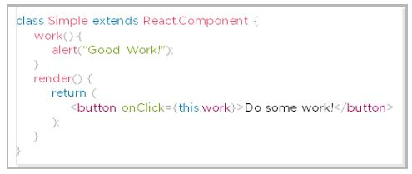

# Top 40 ReactJS Interview Questions and Answers for 2023

Lesson 7 of 8[By Taha Sufiyan](https://www.simplilearn.com/authors/taha-sufiyan)

Last updated on Oct 11, 202250932920



[Previous](https://www.simplilearn.com/tutorials/reactjs-tutorial/flutter-vs-react-native)[Next](https://www.simplilearn.com/tutorials/react-tutorial/guide-to-understanding-react-and-express)

## Table of Contents

[Basic Level - ReactJS Interview Questions](https://www.simplilearn.com/tutorials/reactjs-tutorial/reactjs-interview-questions#basic_level__reactjs_interview_questions)

[ReactJS Interview Questions on Components](https://www.simplilearn.com/tutorials/reactjs-tutorial/reactjs-interview-questions#reactjs_interview_questions_on_components)

[ReactJS Redux Interview Questions](https://www.simplilearn.com/tutorials/reactjs-tutorial/reactjs-interview-questions#reactjs_redux_interview_questions)

[ReactJS Router Questions](https://www.simplilearn.com/tutorials/reactjs-tutorial/reactjs-interview-questions#reactjs_router_questions)

[ReactJS Styling Questions](https://www.simplilearn.com/tutorials/reactjs-tutorial/reactjs-interview-questions#reactjs_styling_questions)

React is quite the buzzword in the industry these days. As of now, [React](https://www.simplilearn.com/tutorials/reactjs-tutorial/what-is-reactjs) is the most popular front-end technology that more and more companies are using, and if you are [preparing for a job interview](https://www.simplilearn.com/ways-to-prepare-for-your-next-job-interview-article), this is ReactJS interview questions tutorial is just the right one for you. Here's a comprehensive list of all the common ReactJS interview questions from basic to advanced levels that are frequently asked in interviews.

Master the fundamentals of React including JSX, props, state, and events. Consider the [React.JS Certification Training Course](https://www.simplilearn.com/react-js-certification-training-course?source=GhPreviewCTAText). Enroll now!

## **Basic Level - ReactJS Interview Questions**

Here are some React Interview Questions on basic concepts.

### **1. What are the features of React?**

|  |  |
| --- | --- |
| JSX react | **JSX:** JSX is a syntax extension to JavaScript. It is used with React to describe what the user interface should look like. By using JSX, we can write [HTML](https://www.simplilearn.com/tutorials/html-tutorial/what-is-html) structures in the same file that contains [JavaScript](https://www.simplilearn.com/tutorials/javascript-tutorial/introduction-to-javascript) code. |
| Components | **Components:**[Components](https://www.simplilearn.com/tutorials/reactjs-tutorial/reactjs-components) are the building blocks of any React application, and a single app usually consists of multiple components. It splits the user interface into independent, reusable parts that can be processed separately. |
| Virtual DOM | **Virtual DOM:**React keeps a lightweight representation of the real DOM in the memory, and that is known as the virtual DOM. When the state of an object changes, virtual DOM changes only that object in the real DOM, rather than updating all the objects. |
| Data binding | **One-way data-binding:**React’s one-way [data binding](https://www.simplilearn.com/tutorials/angular-tutorial/angular-data-binding) keeps everything modular and fast. A unidirectional data flow means that when designing a React app, you often nest child components within parent components. |
| High-per | **High performance:**React updates only those components that have changed, rather than updating all the components at once. This results in much faster web applications. |

#### Post Graduate Program: Full Stack Web Development

in Collaboration with Caltech CTME[ENROLL NOW](https://www.simplilearn.com/pgp-full-stack-web-development-certification-training-course?source=GhPreviewCTABanner)

Post Graduate Program: Full Stack Web Development

### **2. What is JSX?**

JSX is a syntax extension of JavaScript. It is used with React to describe what the user interface should look like. By using JSX, we can write HTML structures in the same file that contains JavaScript code.

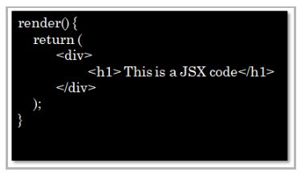

### **3. Can web browsers read JSX directly?**

* Web browsers cannot read JSX directly. This is because they are built to only read regular JS objects and JSX is not a regular JavaScript object
* For a web browser to read a JSX file, the file needs to be transformed into a regular JavaScript object. For this, we use Babel



### **4. What is the virtual DOM?**

DOM stands for Document Object Model. The DOM represents an HTML document with a logical tree structure. Each branch of the tree ends in a node, and each node contains objects.



React keeps a lightweight representation of the real DOM in the memory, and that is known as the virtual DOM. When the state of an object changes, the virtual DOM changes only that object in the real DOM, rather than updating all the objects. The following are some of the most frequently asked react interview questions.

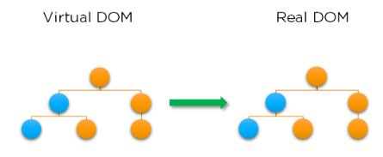

#### Free ReactJS for Beginners Course

Master the Basics of ReactJS[START LEARNING](https://www.simplilearn.com/learn-react-js-basics-free-course-skillup?utm_source=frs&utm_medium=skillup-course-banner&utm_campaign=frs-tutorial-skillup-course-promotion)

Free ReactJS for Beginners Course

### **5. Why use React instead of other frameworks, like Angular?**

|  |  |
| --- | --- |
| Dynamic | **Easy creation of dynamic applications:** React makes it easier to create dynamic web applications because it provides less coding and provides more functionality, whereas, with JavaScript applications, code tends to get complex very quickly. |
| Improved | **Improved performance:**React uses virtual DOM, which makes web applications perform faster. Virtual DOM compares its previous state and updates only those components in the real DOM, whose states have changed, rather than updating all the components — like conventional web applications. |
| Reusable | **Reusable components:**Components are the building blocks of any React application, and a single app usually consists of multiple components. These components have their own logic and controls, and they can be reused through the application, which, in turn, dramatically reduces the development time of an application. |
| Data flow | **Unidirectional data flow:**React follows a unidirectional data flow. This means that when designing a React app, we often nest child components within parent components. And since the data flows in a single direction, it becomes easier to debug errors and know where the problem occurs in an application at the moment. |
| Dedicated | **Dedicated tools for easy debugging:**Facebook has released a chrome extension that we can use to debug React applications. This makes the process of debugging React to web applications faster and easier. |

### 6. What is the difference between the ES6 and ES5 standards?

This is one of the most frequently asked react interview questions.

These are the few instances where ES6 syntax has changed from ES5 syntax:

* **Components and Function**

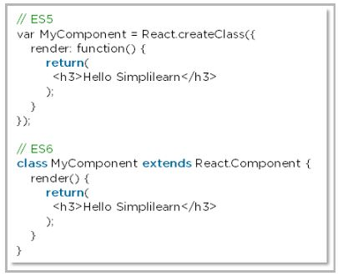

* **exports vs export**

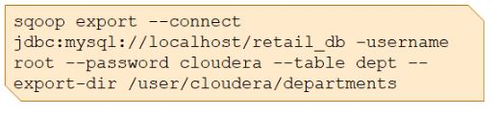

* **require vs import**

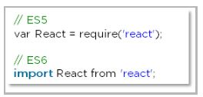

### **7. How do you create a React app?**

These are the steps for creating a React app:

* Install [NodeJS](https://www.simplilearn.com/tutorials/nodejs-tutorial/what-is-nodejs" \o "NodeJS" \t "_blank) on the computer because we need npm to install the React library. Npm is the node package manager that contains many JavaScript libraries, including React.

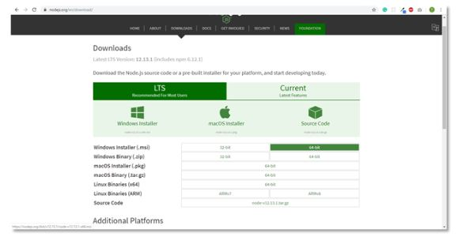

* Install the **create-react-app** package using the command prompt or terminal.

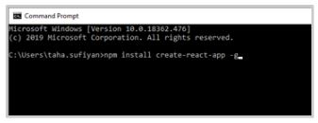

* Install a text editor of your choice, like VS Code or Sublime Text.

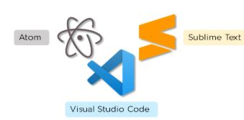

We have put together a set of [Node.js interview questions](https://www.simplilearn.com/tutorials/nodejs-tutorial/nodejs-interview-questions) in case you would like to explore them.Please note, This is one of the most frequently asked react interview questions.

### **8. What is an event in React?**

An event is an action that a user or system may trigger, such as pressing a key, a mouse click, etc.

* React events are named using camelCase, rather than lowercase in HTML.
* With JSX, you pass a function as the event handler, rather than a string in HTML.

|  |
| --- |
| <Button onPress={lightItUp} /> |

#### Full Stack Java Developer Course

In Partnership with HIRIST and HackerEarth[EXPLORE COURSE](https://www.simplilearn.com/java-full-stack-developer-certification-training-course?source=GhPreviewCTABanner)

Full Stack Java Developer Course

### **9. How do you create an event in React?**

A React event can be created by doing the following:



### **10. What are synthetic events in React?**

React has its own event handling system which is very similar to handling events on DOM elements. The react event handling system is known as Synthetic Events. The synthetic event is a cross-browser wrapper of the browser's native event.

* The application is consistent regardless of the browser it is running in. Here, preventDefault is a synthetic event.

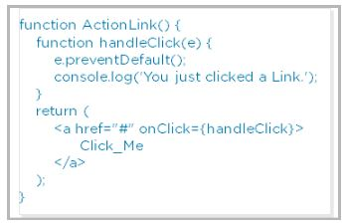

11. Explain how lists work in React

* We create lists in React as we do in regular JavaScript. Lists display data in an ordered format
* The traversal of lists is done using the map() function

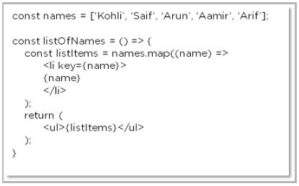

12. Why is there a need for using keys in Lists?

Keys are very important in lists for the following reasons:

* A key is a unique identifier and it is used to identify which items have changed, been updated or deleted from the lists
* It also helps to determine which components need to be re-rendered instead of re-rendering all the components every time. Therefore, it increases performance, as only the updated components are re-rendered

13. What are forms in React?

React employs forms to enable users to interact with web applications.

* Using forms, users can interact with the application and enter the required information whenever needed. Form contain certain elements, such as text fields, buttons, checkboxes, radio buttons, etc
* Forms are used for many different tasks such as user authentication, searching, filtering, indexing, etc

### **14. How do you create forms in React?**

We create forms in React by doing the following:

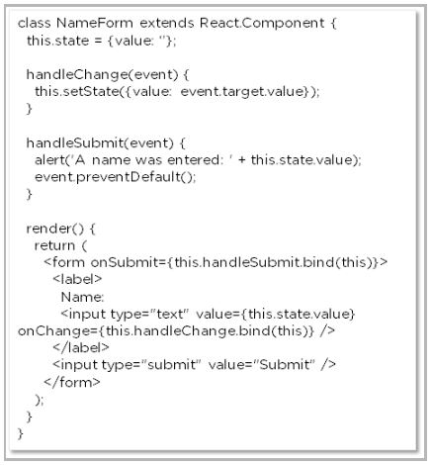

The above code will yield an input field with the label **Name**and a submit button. It will also alert the user when the submit button is pressed.

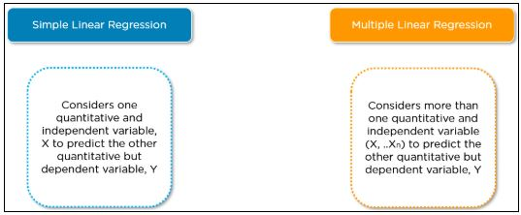

16. What is an arrow function and how is it used in React?

* An arrow function is a short way of writing a function to React.
* It is unnecessary to bind ‘this’ inside the constructor when using an arrow function. This prevents bugs caused by the use of ‘this’ in React callbacks.

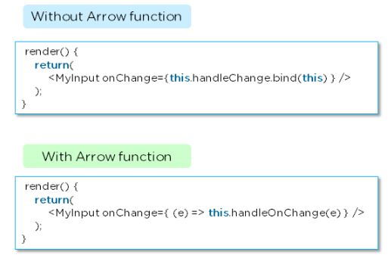

### **17. How is React different from React Native?**

|  |  |  |
| --- | --- | --- |
|  | **React** | **React Native** |
| Release | 2013 | 2015 |
| Platform | Web | Mobile – Android, iOS |
| HTML | Yes | No |
| CSS | Yes | No |
| Prerequisites | JavaScript, HTML, CSS | React.js |

### **18. How is React different from Angular?**

|  |  |  |
| --- | --- | --- |
|  | **Angular** | **React** |
| Author | Google | Facebook |
| Architecture | Complete MVC | View layer of MVC |
| DOM | Real DOM | Virtual DOM |
| Data-Binding | Bi-directional | Uni-directional |
| Rendering | Client-Side | Server-Side |
| Performance | Comparatively slow | Faster due to Virtual DOM |